Table of Contents

1.0 Introduction 2

1.0 Purpose of this document 2

2.0 Definitions & Acronyms 3

3.0 Project Overview 3

4.0 Scope 3

5.0 Hardware and Software Requirment 3

2.0 System diagram 4

3.0 Design for Displaying Movie Details (HomePage) 4

1.0 Requirement flow 4

2.0 Technical guidelines 5

Component Specification – Model 6

4.0 Design for Adding New Movie Details to the database 7

1.0 Requirement flow 7

2.0 Create Movie 9

3.0 Technical guidelines 11

5.0 Custom exception filter 12

6.0 Standards and Guidelines 13

1.0 Controller & View 13

7.0 Design constraints 14

8.0 Code submission Instructions 14

9.0 Evaluation Areas 14

# Introduction

## Purpose of this document

The purpose of this document is to define the server side implementation of the MovieManagement application.

## Definitions & Acronyms

|  |  |
| --- | --- |
| Definition / Acronym | Description |
| ASP.NET MVC | ASP.Net MVC is a Web development framework built on top of ASP.Net with certain changes in the internal workings of web page rendering |

## Project Overview

You have been assigned a task to create pages that allow the administrator to add, edit, and delete movie details. In addition, you have to create a Web page that displays a list of added movies. The Movie details are stored in the database. All the Movie details are retrieved from the database and displayed on the screen.

Use Case Diagram

Admin

Create New Movie

View Existing Movies

## Scope

1. Creation of ASP. Net MVC web application for MoviesManagement application

## Hardware and Software Requirement

1. Hardware Requirement:
   1. Developer PC with 8GB RAM
2. Software Requirement
   1. IE or Chrome
   2. .NET Framework 4.5
   3. Visual Studio Professional Edition 2015
   4. SQL Server enterprise edition 2014

# System diagram

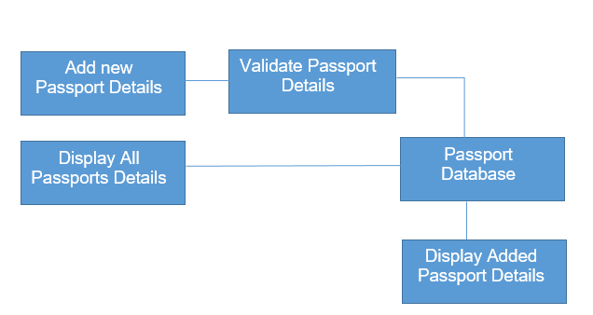

# Design for Displaying Movie Details (HomePage)

## Requirement flow

**Steps Explanation**

1. Application admin launches the application.
2. The page is displayed with Movie details retrieved from the database. This is the default homepage*.*